**OOP Lab #3**

**Methods or Functions in C#**

**Method:**

* A method is a group of statements that together perform a task.
* Methods are functions declared in a class and may be used to perform operations on class variables.
* They are block of code that can take parameters and may or may not return a value.
* It is use to perform specific tasks.
* Methods are reusable

Example of Code instance / non-static method

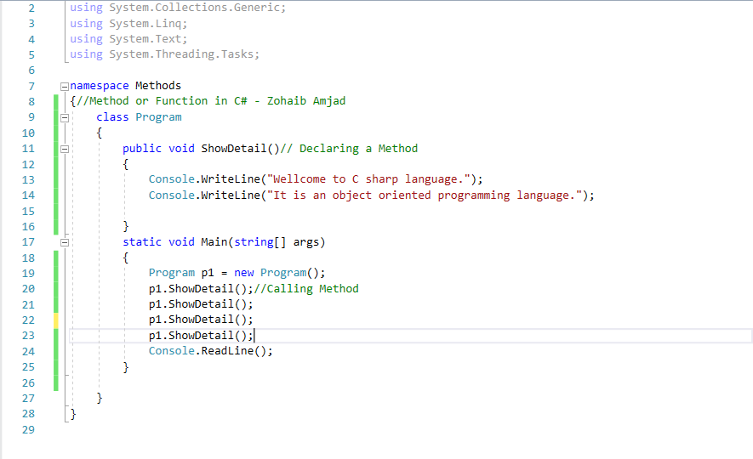

Output by calling it many times

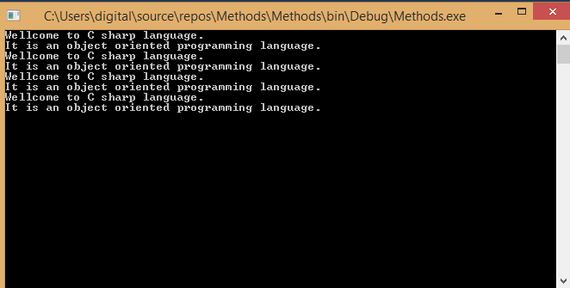

Static Method Code Example

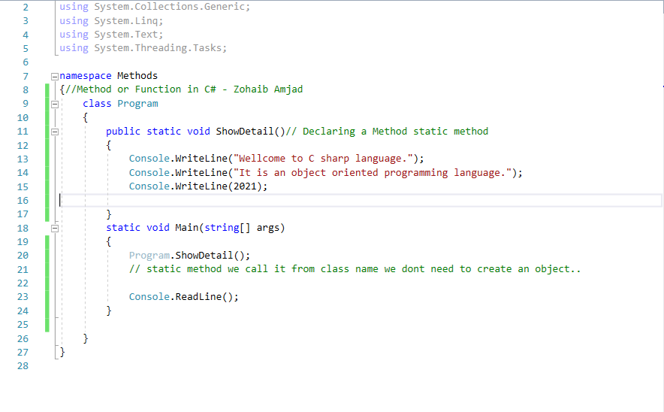

Output

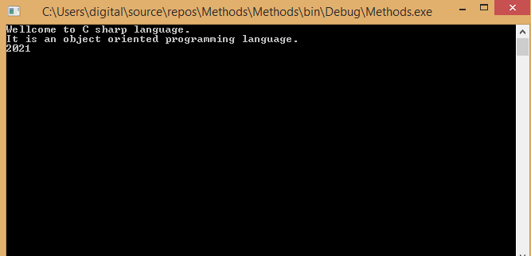

Parameterized Static Method Code Example

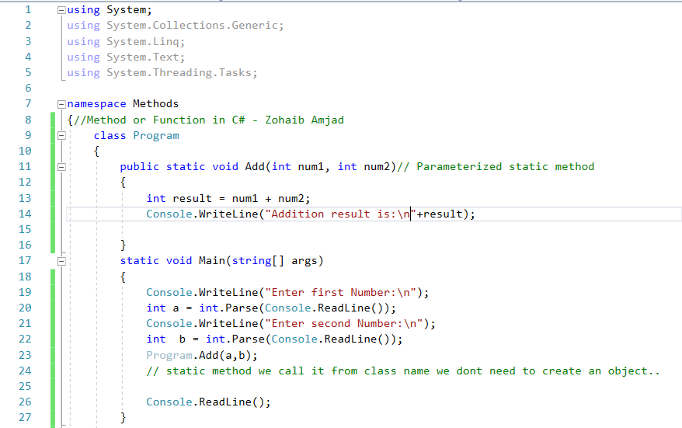

Output

